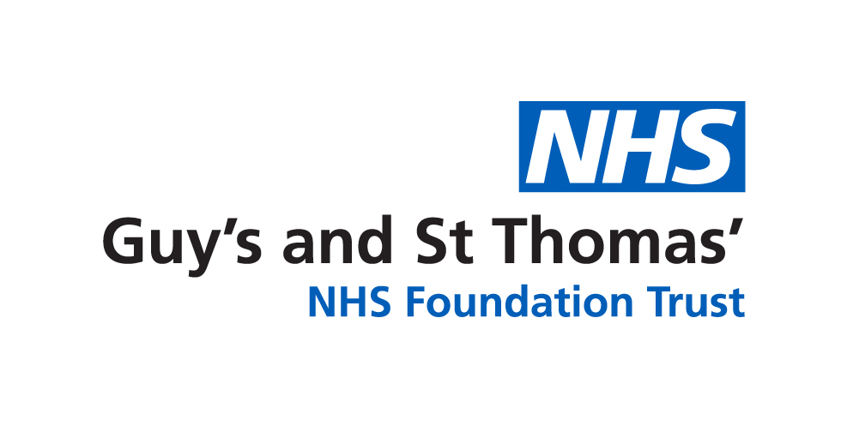

Centre for Preimplantation Genetic Diagnosis at Guy’s Hospital

Patient Referral Form

Please complete as fully as possible. Incomplete forms and missing data may result in a delay for your patients

Please check the below list to ensure your patients are eligible for NHS-funded treatment. If you have any queries about eligibility, you may wish to contact us before referring.
Referral criteria

Criteria | Tick or NA
Female patients must be under 40 years at start of treatment. It is not always be possible to offer PGD to women over 39 years of age.
Female body mass index (BMI) must be over 19 and under 30.
Couple must have been in a stable relationship for at least 1 year and living at the same
address.(do not have to be living together for a year)
Molecular diagnosis must have been confirmed in a UKAS accredited NHS laboratory.
Pathogenicity of mutation must have been determined by referring centre—class 4 or 5 variants only accepted.
Couple must be non-smokers or be willing to complete an NHS Smoking Cessation
Programme.
Couples with healthy children together will be accepted but must understand they will
not be eligible for NHS funding.
Parents of de novo cases must have been tested where possible to exclude gene carrier status.

To set up PGD our laboratory, we usually will require DNA samples from family members across two generations. Please tick to confirm you have sent the following molecular genetic reports with the initial referral.

Autosomal Dominant | Please tick one
Carrier partner and affected child/pregnancy
Carrier partner and affected parent
Autosomal Recessive
Carrier couple and affected child/pregnancy
Carrier couple and couple’s parents (carrier status confirmed)
X-Linked Recessive or Dominant
Carrier partner and carrier child
Carrier partner and carrier parent
Chromosome Rearrangement
No DNA samples required but please send report of carrier partner and affected child (if relevant)
PGD Patient Referral Form—Guy’s Hospital
Date of referral:
Referring Clinician Details
Name:

Address:

Tel:
Email:
Patient details: Partner 1 Partner 2
Name:  DOB:  Gender:  NHS No:  Tel No:  Email: |  |  | Name:  DOB:  Gender:  NHS No:  Tel No:  Email:
GP Name and Postcode
Your reference number
Address of couple:
Diagnosis and
Phenotype OMIM number
History (family history, relevant obstetric/fertility details, miscarriage investigations, previous children, and health of patients affected by genetic conditions)
*** Please include:
- female BMI
- interpreter needed?
- is de novo status confirmed?
Please attach the following to this form when making a referral:  (Please note - will delay process if not included) |  | - Molecular or cytogenetic laboratory report from proband & other affected family members if possible (essential for proband)  - Copy of family tree  - Any email correspondence you have had with us  - Information about both partners or indication that the patient is undergoing PGD as a single person
Send form to:  PGD Genetics Counsellors  Clinical Genetics Department  7th Floor, Borough Wing, Guy’s Hospital, Great Maze Pond, London, SE1 9RT or Email: gst-tr.pgdenquiries@nhs.net |  |  |  | If you would like to discuss a referral before sending please contact the PGD team on:  Tel: 020 7188 1364 or  Email: gst-tr.pgdenquiries@nhs.net

